Lab Report No 7

Digital to Analogue Converters


Spring 2026
CSE-420L Embedded Systems Lab

Submitted By: Naveed Ahmad
Registration No: 22PWCSE2165

Section: B

“On my honor, as student of University of Engineering and Technology, I have neither given nor received unauthorized assistance on this academic work”

Submitted to:
Engr. Muhammad Shahzad
May 3, 2026

Department of Computer Systems Engineering
University of Engineering and Technology Peshawar

Objective
The objective of this lab is to understand the working principle of Digital-to-Analogue Converters (DAC), explore different types of DAC implementations, and implement DAC functionality on Arduino UNO using PWM (Pulse Width Modulation) since Arduino UNO does not have a built-in DAC. The lab also covers how hardware registers are used to configure and control DAC and PWM on microcontrollers

Components Required
- Arduino UNO — Main microcontroller board (ATmega328P)
- MCP4725 — External I2C DAC module (12-bit resolution)
- LED — For observing analogue output (brightness variation)

• LDR (Light Dependent Resistor) — As sensor input for Task 02
- Resistors — 10kΩ (pull-down for LDR), 220Ω (current limiting for LED)
- Jumper Wires — For circuit connections on breadboard
- Breadboard — For prototyping the circuit
- USB Cable — For programming and powering the Arduino

Theory

Digital-to-Analogue Converter (DAC)
A Digital-to-Analogue Converter (DAC) is a device that converts a digital binary value into a proportional analogue voltage. DACs are essential in embedded systems whenever a microcontroller needs to produce a continuously variable output — for example, to drive a speaker, control motor speed, or set a reference voltage for a sensor. The output voltage of a DAC is determined by the following formula:

Vout = Vref × (Digital Value / 2ⁿ)
Where Vref is the reference voltage, Digital Value is the binary input, and n is the number of resolution bits. For example, if the digital value is 128 with an 8-bit DAC and Vref = 5V, then Vout = 5 × (128/256) = 2.5V — exactly half the reference voltage.

DAC on Arduino UNO (PWM Method)
The Arduino UNO (ATmega328P) does not have a built-in hardware DAC. To simulate an analogue output, it uses PWM (Pulse Width Modulation). PWM works by switching a digital output on and off at a fixed frequency, varying the duty cycle (the percentage of time the signal is HIGH). When passed through a low-pass RC filter, a PWM signal approximates an analogue voltage proportional to the duty cycle. The key hardware registers used for PWM on the ATmega328P are:

- TCCR0A — Timer/Counter Control Register A: configures the timer mode (Fast PWM or Phase Correct) and the compare output mode.
- TCCR0B — Timer/Counter Control Register B: sets the clock prescaler which determines PWM frequency.
- OCR0A / OCR0B — Output Compare Registers: hold the duty cycle value (0–255 for 8-bit). The timer compares this value to its counter to determine when to toggle the output.

DAC Using External IC: MCP4725
For true analogue output, the MCP4725 is a 12-bit external DAC module that communicates with the Arduino via the I2C protocol. It provides a genuine continuous analogue voltage output (0 to Vcc) with 4096 steps of resolution. This is used when precise, smooth analogue signals are needed, such as generating waveforms or driving analogue sensor inputs for testing.

Microcontrollers with Built-in DAC
Several modern microcontrollers include hardware DAC modules natively, eliminating the need for PWM approximation or external ICs:
- ESP32 — 2-channel 8-bit DAC on GPIO25 and GPIO26
- STM32 (selected variants) — 12-bit DAC with DMA support
- PIC (selected models) — 8-bit or 10-bit DAC on specific modules
These microcontrollers use dedicated hardware registers to configure and control the DAC output. The key registers are:
- DAC_CR — Control Register: enables the DAC channel and selects the trigger source.
- DAC_DR — Data Register: stores the digital value to be converted to analogue output.
- DAC_SR — Status Register: indicates the current state of the DAC conversion process.

ADC vs DAC Comparison

Feature | ADC (Analogue-to-Digital) | DAC (Digital-to-Analogue)
Function | Converts analogue signal → digital | Converts digital value →  analogue signal
Input | Analogue voltage | Binary / digital number
Output | Binary digital value | Analogue voltage

Primary Use | Reading sensors (temperature, light) | Driving actuators, audio, motor control
Arduino UNO | 6 channels, 10-bit (A0–A5) | No built-in DAC — uses PWM instead
Resolution Example | 1024 steps (10-bit) | 256 steps (8-bit) / 4096  (MCP4725)

TASK 01: Generate PWM signal
Register used must be TCCR0 , TCCR0A , TCCR0B
Code:
// Task 01: Generate PWM signal using hardware registers // PWM on PD6 (Arduino Pin 5) using Timer0

void setup() {
// Set PD6 as output
DDRD |= (1 << PD6);

// Configure Timer0 for Fast PWM, non-inverting mode
// WGM00 = 1, WGM01 = 1 => Fast PWM
// COM0A1 = 1 => Non-inverting output on OC0A (PD6)
TCCR0A = (1 << COM0A1) | (1 << WGM01) | (1 << WGM00);

// Set prescaler to 64
// CS01 = 1, CS00 = 1 => clk/64
TCCR0B = (1 << CS01) | (1 << CS00);

// Set duty cycle to ~50% (127/255)
OCR0A = 127;
}

void loop() {
// PWM runs automatically via hardware — no loop code needed
4

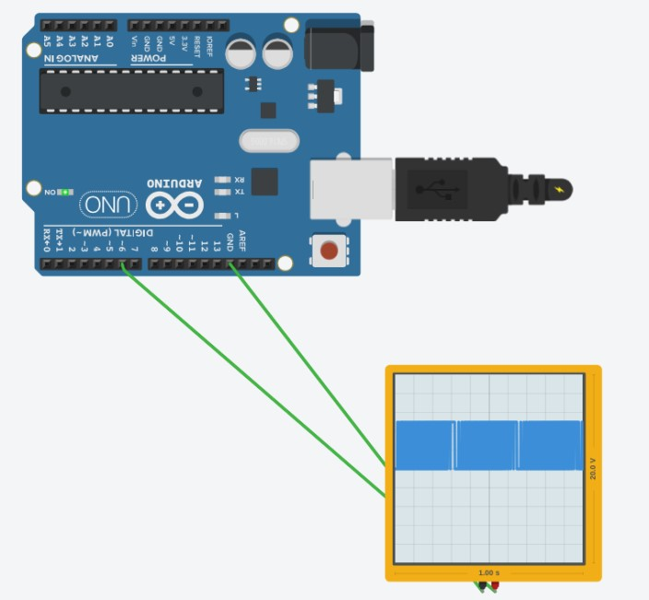

5

}

